**DoS attack implementation**

**Implementation**

There were two basic necessities for the attack to work. The program was supposed to be able to send get requests to server and this requests were supposed to be threaded for it to rapidly access the server.

Python was used in implementing this requirements using the urllib.request and threading module.

Basically a new class was created to extend the threading class and implement the get requests that should be sent to the server and a main script was written to import this class and run the defined threads based on the users request.

**Testing**

The program was tested on xender’s connect to pc wifi network.

Before the DoS Attack

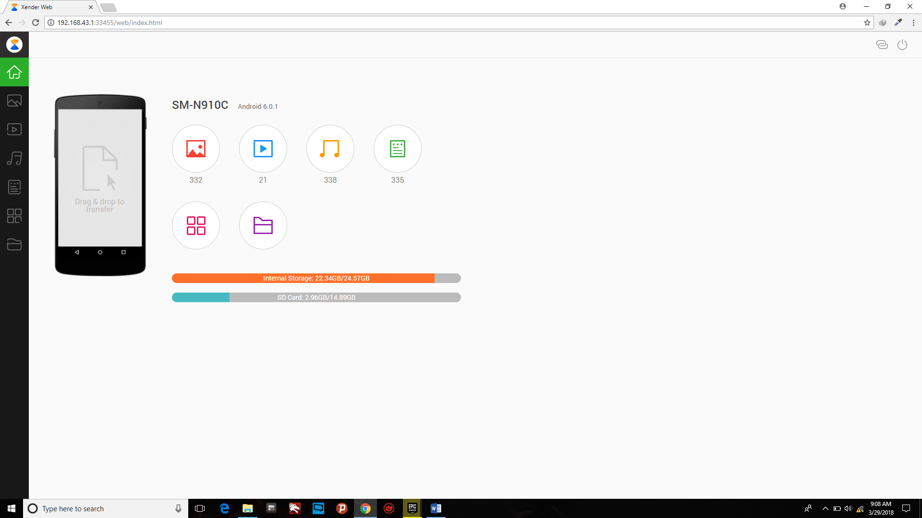

**Attack Script Running**

